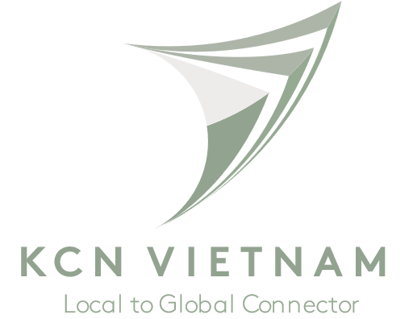

Employer: KCN VIETNAM
Title of Internship: Content Writing Intern
Division: Sales and Marketing
Location: Level 10, 117 Nguyen Cuu Van, W.17, Binh Thanh Dist., Ho Chi Minh City, Vietnam.
Full Time, Summer 2022
Stipend
Description
KCN Vietnam is a leading industrial real estate developer, providing ready-built factories and warehouses for investors looking for industrial properties. We have projects across the north and south of Vietnam, with over 250 HA of land in our landbank. Currently, we are rapidly expanding our team and we are looking for dynamic young interns to join us!
Responsibilities
- Develop related content for multiple platforms, such as websites, email marketing, product descriptions, videos, and social media
- Write copy for a variety of media, including social, print, video, and online
- Collaborate with creative, product, marketing, to assess project needs and help with messaging
- Working with KCN team for press/ news releases if any

Qualifications:
BSc in Marketing, English, Journalism or related field
Excellent writing and editing skills in English and Vietnamese

